**Designing a soldering station**

|  |  |
| --- | --- |
| Author | Sem Kirkels |

Content

1 Introduction 1

2 Material and methods 2

2.1 Materials 2

2.2 Methods 2

2.2.1 Software 2

2.2.2 Step by step 3

3 Results 4

3.1 Schematic design 4

3.1.1 Power supply 4

3.1.2 The controller circuit 5

3.1.3 The amplifier circuit 5

3.1.4 The processor 6

3.1.5 The display circuit 7

3.2 PCB Design 7

3.3 Case design 8

4 Discussion 8

4.1 Difficulties 9

4.2 Self-reflection 9

5 Reference list 9

# Introduction

For this project a soldering station is designed. The soldering station is characterized by its ability to heat up quickly. The rapid heating can only be achieved by the combination of the soldering iron and the 80 VA transformer. Another feature is the ability to select the appropriate soldering temperature.

A soldering station is a tool used to solder components on to a PCB. It is a useful tool for future projects. An article found in the Elektor magazine describes the steps needed to build a soldering station.

This application note gives an overview of the design process and its difficulties.

# Material and methods

In this chapter the materials and methods used to build a soldering station will be discussed. To build the soldering station a number of components are needed. These components are summed up in a bill of materials. There are also two different software programs needed to realize the soldering station.

## Materials

The Original design as found in the magazine uses through hole components. These components tend to be larger and less expensive. To reduce the formfactor and the time needed to solder the components modern SMD components are used. SMDs are smaller and can be soldered using a special soldering oven. Because of the small formfactor the custom circuit board is less expensive and the case is smaller. The bill of materials below gives more details about the components.

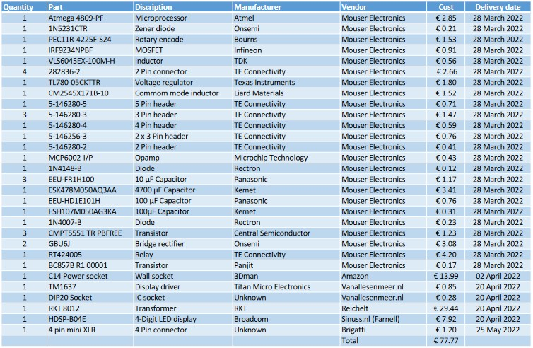

Figure 1: Bill of materials

## Methods

### Software

There are two software tools used to design this project. These are Altium Designer and SolidWorks

Altium Designer is a program used to draw a schematic of the electrical system and design the PCB. It is a professional program that is widely used in the field. This software is able to create libraries. This creates a clear list of components and footprints. Therefor the user is able to use the same symbol and footprint for the same component type. Because of that the user can easily edit one symbol and update the others.

SolidWorks is a CAD program that is used to make 3D drawings. This software has a build-in toolbox. The toolbox gives the designer a list of parts such as nuts and bolts that can be inserted in the design quickly. In this software the user is able to create multiple parts and assemble them virtually. This allows the designer to check for any errors in the design.

### Step by step

To start designing the soldering station the first step is to analyse the schematic and check for through hole components that can be replaced with SMDs. The second step is using datasheets to find suitable replacements.

The third step is downloading and inserting footprints in to Altium Designer. This is necessary to construct a library of all the components. Drawing a schematic using the library and the magazine is the fourth step. When the schematic is ready, components can be ordered which concludes the fifth step.

Then the PCB is designed using the schematic. The PCB is now ready to be ordered.

When the PCB design is ready and ordered designing the case is the next phase. Designing the case is a process that involves the use of SolidWorks Cad software. With this software, a drawing is made. The drawing than is converted to an STL file. The 3D printer uses this file to print the case.

The assembly phase begins. The SMD components are mounted on to the PCB using an SMD oven. Than the remaining through hole components are mounted by hand. Next the transformer is attached to the input on the PCB. Finally everything is mounted in the case and the soldering station can be tested.

Below, the process is schematically displayed.

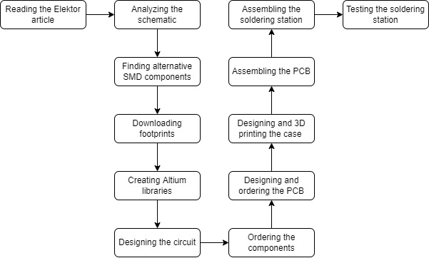

Figure 2: Schematic representation

# Results

## Schematic design

To ensure that the schematic will remain clear. The schematic is split up into different areas. These areas are: the power supply, the controller, the amplifier, the processor and the display. Each area has a specific purpose and that will be discussed in this chapter.

### Power supply

The first zone is the power supply as seen on Figure 3. This area receives 12 volt AC on connector CN1 and CN2. This then gets rectified by the bridge rectifiers B1 and B2. After the rectifier the output voltage is split up into two outputs. The output of B1 is filtered and regulated to 5 volt. The output of B2 is filtered and will stay either 12 volt or 24 volt. The output voltage of B2 depends on the connected soldering iron. The processor which will be discussed later switches the relay RE1 and that will change the output voltage VIN.

The 5 volt output is used to power the integrated circuits on the PCB. The VIN output is used to power the soldering iron.

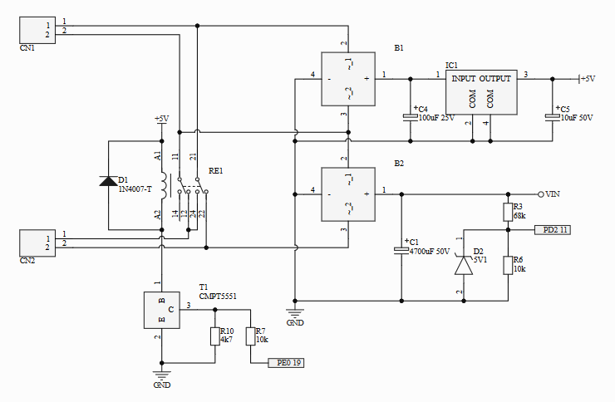

Figure 3: Power supply

### The controller circuit

The controller that is seen on Figure 4 is the part of the station that controls the heat of the soldering iron. The output voltage on the connector CN8 is regulated by this part of the circuit. When transistor T4 is powered it creates a low resistance path to ground. Transistor T2 will close and T5 will open. Since the gate of T3 is now connected to ground it will close. When transistor T4 is not powered T3 will be powered.

Figure 4: Controller

### The amplifier circuit

The amplifier circuit seen below receives a signal from the thermocouple of the soldering iron. This signal is amplified by the circuit so that the processor can register it and convert it to the current temperature of the soldering tip. Depending on the type of soldering iron the signal is amplified 361 times or 181 times.

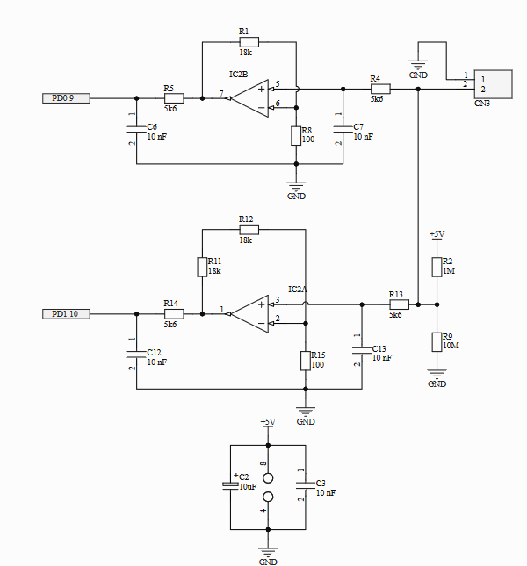

Figure 5: Amplifier circuit

### The processor

The processor circuit is the most important part of the soldering station. The ATmega IC3 seen on Figure 6 is the main IC on the PCB and controls the other areas. The circuit has a lot of connectors that are not used however they can be programmed.

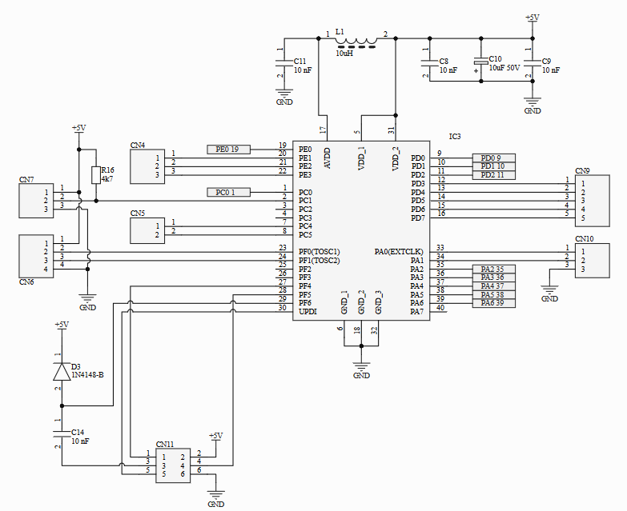

Figure 6: The processor circuit

### The display circuit

The final area is the display circuit. This area consists out of two parts. The first part seen on Figure 7 on the left side is the rotary encoder. The encoder is the user interface. It allows the user to change settings such as the type of soldering iron and the temperature. The second part is the display driver TM1637 and the display.

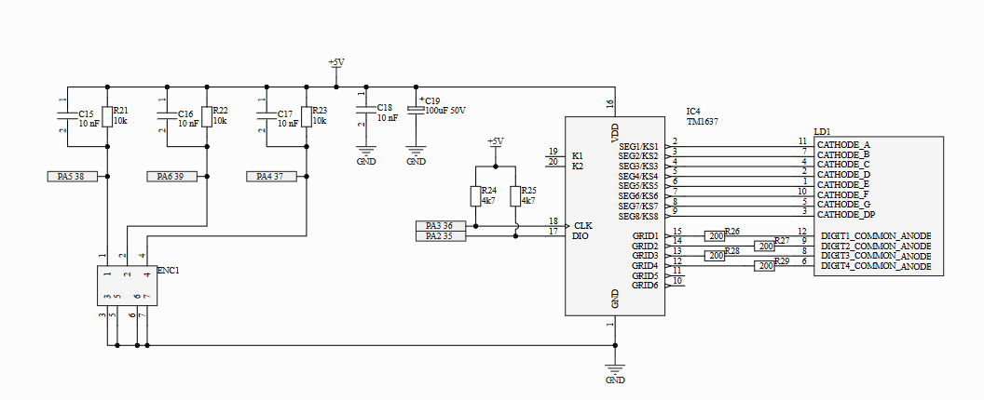

Figure 7: Display circuit

## PCB Design

When the schematic design is finished, the PCB design is the next step. All the components are placed on to the PCB and then traces are laid. Almost all the traces are 20 mil or 0.508 mm wide. The traces of the input are wider (50 mil or 1.27 mm) because of the higher current that passes through them.

Figure 8: PCB Design

## Case design

The case is made out of different parts. Each side is designed separately this allows for easy installation of the PCB, wall adapter, transformer and connector. Another advantage of designing loose parts is the 3D-printing. When a print fails only one side has to be reprinted. In Figure 9 the small tolerances of the case and the PCB are visible. The small tolerances reduce the material usages and cost.

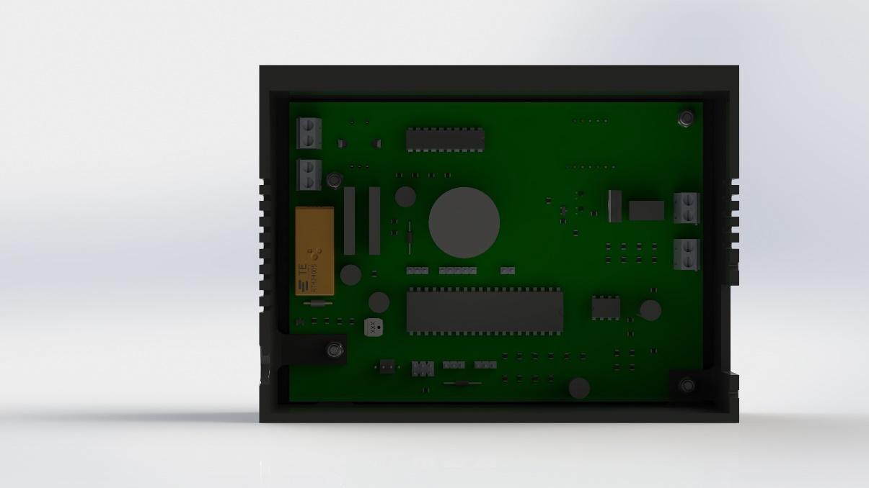

Figure 9: Case tolerance hight and width

In Figure 10 the depth tolerance is visible. The transformer (1) on the right has just three centimetres tolerance to the capacitor (2) on the left side of the case.

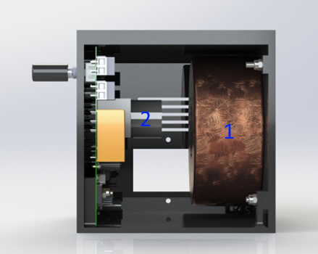

Figure 10: Case tolerance depth

# Discussion

During the process there are a number of problems that can be encountered. One of the first problems is the lack of correct symbols of the components that can be found online. When a wrong symbol is used this fault is implemented in the PCB design.

While designing a PCB using the wrong footprints is a problem that can be encountered. Checking each footprint prevents mistakes like this.

## Difficulties

During the schematic design process, the symbols were not checked. The collector and base of the transistors were swapped. As a result, there were errors in the PCB design that were found only after the PCB had been delivered. The SMD transistors are swapped for through hole transistors which are soldered on to the SMD pads.

Another error is the P-channel MOSFET. When using it the output for the soldering iron gets no variable signal. The MOSFET is replaced by an N-channel MOSFET, the output does work.

The last problem is a delivery error. The wrong 7-segment display was send by Mouser. This problem is not solved yet, because the display has not been delivered yet.

## Self-reflection

The project was more difficult than initially expected. The difficulty lay in finding the through hole components and replacing them with an SMD alternative. For this the datasheets have to be checked and the replacements must have identical specifications. With the current chip shortage its harder to find suiting replacements for a reasonable price.

If I were to do the project again, the symbols would be checked for errors. Also the orders should be checked with the corresponding datasheet for each component to prevent any delivery errors.

# Reference list

|  |  |
| --- | --- |
| [1] | X, “Soldeerstation 2021,” *Elektor magazine,* vol. 2021, no. 1, p. 116, 2022. |